Brooklyn College
The City University of New York

Department of Communication Arts, Sciences and Disorders

CASD 1643 M3 Visual Communication
3 hours; 3 credits
Fall 2021

Prof. Sharona A. Levy Telephone: 718-951-5225
E-Mail: slevy@brooklyn.cuny.edu Office Hrs.: Mondays 12:30-1:30pm
On Zoom

Course description
Historical, physiological, perceptual and cognitive aspects of visual communication. Broad and diverse approaches to visual perception, reception and persuasion including theoretical perspectives, critical analysis methods, and ethical implications.

Anticipated student learning outcomes: Students taking this course will develop the following skills:
- Identify principles and apply theories in the use and presentation of images and information.
- Describe how symbols are created, their cultural significance and usage.
- Summarize the fundamental structures and components of successful visualizations and imagery as communicative artifacts.
- Interpret visualizations as powerful tools for conveying information, storytelling, and propaganda.
- Assess the social, cultural and psychological power of visualizations and ways that they can be structured or manipulated to elicit specific reactions.
- Recognize the challenges of unstated and unconscious biases underlying visualizations and their contexts.
- Demonstrate an understanding of the diversity of groups in a global society in relationship to visual culture and communication.
Course Basics
This class meets online: synchronously Mondays 3:40-4:55pm on Zoom and asynchronously the rest of the week through Blackboard.
I am available for virtual office hours on Mondays from 12:30-1:30pm. The Zoom link will be posted under Contacts and on the Announcements page.
You can contact me by email, and I will respond within 24 hours. On weekends and holidays, it may take longer than 24 hours to reply. I am happy to meet with you individually on the phone or on Zoom.
Because the class takes place online, technical problems can have serious impact on your coursework. Reach out to the Brooklyn College helpdesk (helpdesk@brooklyn.cuny.edu) if you have problems with Blackboard or other Brooklyn College systems and let me know. For any other problems or issues with the course, do not hesitate to contact me.
Textbook and Materials
There is no required textbook for this class.

Course texts and material (readings, videos, animations, etc.) are available through Blackboard; for some readings, your Brooklyn College library account may be necessary for access for some texts; you will be able to find the material/texts themselves or links to them both in the learning units and in Course Documents.

Required technology
For the most part, you will only need technology that will allow you to access Blackboard and other websites for this course and a device that has audio and video capabilities. You will also be maintaining a blog and creating digital material. If your internet connection is spotty, try to have a stable connection or not use WIFI when you are taking any quizzes or attending live meetings. If you need digital storage, consider signing up for a free CUNY Dropbox account (http://info.brooklyn.cuny.edu/confluence/display/technology/Digital+Toolbox#DigitalToolbox-Dropbox) or a free CUNY Microsoft 365 cloud services account (http://www.brooklyn.cuny.edu/web/academics/technology_students/MSOffice365students.php).

Course Outline
See CASD 1643 Visual Communication Course Outline document for a comprehensive weekly course outline. The Course Outline will be reviewed during our first Zoom meeting on Monday, August 30. The course outline is subject to change.

In general, assignments are due Fridays by 12 pm noon Eastern Time – blog posts, specified discussion boards posts, and homework assignments (except on holidays)

Method of evaluation
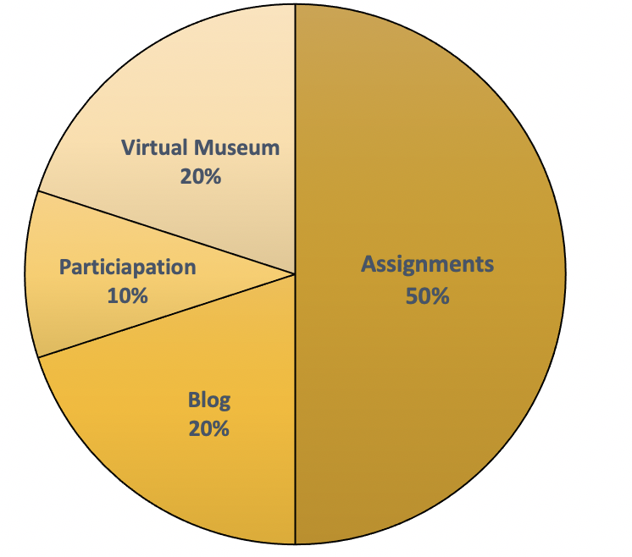
Grades will be determined by students’ assignments (50% of final grade), students’ end of semester group project and presentation (20% of final grade), student blogs (20% of final grade) and class participation (10% of final grade). There are no extra-credit assignments. This class does not grade on a curve.

Method of assessment
Individual and group assignments, a virtual museum presentation, student blog, and class participation consisting of discussion board posts and blog comments are used to assess students’ mastery of the specific course topics as well as critical thinking and analytical skills.

Course methodology
This class will be working online synchronously and asynchronously. Many activities involve students engaging with each other’s work online, so it is important to get your assignments in by their due dates. This way your work is fully able to contribute to the work of the whole class. If work is posted at the last moment or late, it will be hard for you to fully take part in the activities and conversations.

In commenting on your classmates’ work for this class, you generally should follow these guidelines: 1) Add information that wasn’t included in their answer/response; 2) Correct an error they made; or 3) Relate their answer to a current event or other material. Responses to another student’s work must be respectful, but that doesn’t mean that you have to agree with what they wrote. Limit any disagreements to the ideas, positions, and logic used. No credit is given for simply writing something like: “You did great,” “I disagree,” or “I like your answer.”

Each student will need to manage their own time each week, to know when assignments are due, and any other weekly course obligations. To be successful regularly log into the online learning systems to check the unit assignments, forums, announcements, and check your email.

Connection blog
Your personal blog makes up a large percentage of your course grade (20%), so you should commit attention and energy to this semester-long activity. If anything isn’t clear, ask questions.

- You will create and maintain a blog, posting a personal response biweekly to something that came up in the week’s readings, homework or class; at times I will ask you to post something on a specific topic.
- Your blog must be public, but you should not post anything you would not be comfortable having someone you know see or read. Once you make it accessible/public, send me the link.
- Your post should be about 250-350 words long and contain visuals as well. Think about the differences between keeping a written journal and an online journal that everyone can read. A good blog takes advantage of the online environment with relevant audiovisuals and links.
- Pick a good title for your blog that is meaningful to you and may catch your audience’s attention; do NOT call your blog “CASD 1643,” “My Blog,” “Visual Communication Connection,” etc. Remember your title is the first thing anyone sees or reads (first impressions). Many sites let you have a tagline or subtitle as well, so take advantage of that extra signage space.
- Blog postings will be due by noon (12:00 pm Eastern Time) on Fridays unless that day is a holiday.
- Your blog posts will be evaluated using a rubric that you will help develop.
- You are expected to explore your classmates’ blogs and comment on them throughout the semester. Links to all the blogs will be posted on Blackboard. Your comments should be substantive. If you aren’t sure what to write, follow the 3CQ format: each comment should include a compliment, a comment, a connection (3C) and a question (Q).

You can use any free site such as WordPress, Blogger or Wix. A good site for setting up a free blog is Edublogs (http://edublogs.org), an Australian site designed for teachers and students, which has lots of free templates to choose from. You can also use an existing blog you’ve created either personally or for a previous class if it would be appropriate to use it for this class.

Preferred name and gender pronouns
All people have the right to be addressed in accordance with their personal identity. In this class, you can indicate the name that you prefer to be called by and pronouns by which you would like to be addressed. I will do my best to refer to all students accordingly as well as support classmates in doing so.
Student accommodations
To receive disability-related academic accommodations, students must first be registered with the Center for Student Disability Services which is currently working remotely. Students who have a documented disability or suspect they may have one are invited to set up an appointment with the Director of CSDS, Ms. Valerie Stewart-Lovell, at 718-951-5538 or emailing testingcsds@brooklyn.cuny.edu. If you have already registered with CSDS, email Josephine.Patterson@brooklyn.cuny.edu or testingcsds@brooklyn.cuny.edu to ensure the accommodation email is sent to your professor.

Student Bereavement Policy
CUNY and Brooklyn College have a student bereavement policy. If a student wishes to or needs to use either the Standard Bereavement Procedure or the Leave of Absence Bereavement Procedure, the student must contact the Division of Student Affairs, 2113 Boylan Hall, 718-951-5352, studentaffairs@brooklyn.cuny.edu. See http://www.brooklyn.cuny.edu/web/about/initiatives/policies/bereavement.php for details.

Academic integrity
Plagiarism and cheating are unacceptable and will result, at minimum, in a grade of F or 0 for that assignment, quiz or test and, more severely, a grade of F for the course. “The faculty and administration of Brooklyn College support an environment free from cheating and plagiarism. Each student is responsible for being aware of what constitutes cheating and plagiarism and for avoiding both. If a faculty member suspects a violation of academic integrity and, upon investigation, confirms that violation, or if the student admits the violation, the faculty member MUST report the violation.” The complete text of the CUNY Academic Integrity Policy and the Brooklyn College procedure for policy implementation can be found at: www.brooklyn.cuny.edu/bc/policies. Students should be aware that faculty may use plagiarism detection software.

Course policies, resources and advice
- If you have any questions, technical difficulties, or problems with the course or material, please reach out to me by email or phone. With online classes move you need to establish a routine to work through the course content. If you find yourself falling behind, don’t hesitate to contact me.
- Download a copy and read through the Syllabus. Mark anything you think is important or that you have a question about. Each course unit in Blackboard will have an Overview and To-Do List at the beginning of the unit so you understand the rhythm of the course and what is expected. This should help you to plan your time and work. There is coursework to do throughout the week.
- There will be a Q&A discussion board on Blackboard that will remain open for you to use throughout the semester. You can post anonymously any questions you have about the class, units, readings, assignments, etc. Posting on the Q&A Discussion Board may get a faster answer than emailing me because another student may be able to answer your question before I do. Or you may see that someone else asked a similar question and received an answer that solves your issue.
- Regularly check your college email or the email that is associated with Blackboard as that is where class emails will go automatically. If this is not an account that you use, make sure to change the email listed for you.
- Submitting written assignments and classwork on time is essential to success in this class. Late assignments may be penalized. Generally, you will not be given the opportunity to revise and resubmit assignments that are at a satisfactory level (C or better). Questions about points for exams, quizzes or assignments must be asked within one (1) week of the date the points or grade is assigned (posted on Blackboard). You can access your grades under the “My Progress” link on the menu.
- You are responsible for watching videos, completing readings and other homework assignments assigned. Absence should not be an excuse for not completing assignments: you can always check our Blackboard site for the class assignment or contact me through email.
- Homework assignments are to be typed unless otherwise stated. Name, date and class should be at the top of the first page and your name at the top of subsequent pages. The text should be in Times New Roman 12 point and double spaced with one-inch margins on all sides. Assignments should be submitted through Blackboard using SafeAssign.
- Emails should have your full name and the class in the subject heading and in the body of the email so that it is clear whom the email comes from.
- You are expected to interact collaboratively and respectfully with your peers on matters relating to the class. There will be group work throughout the semester. Working respectfully with your classmates is an integral part of the class.
- Read carefully the section entitled “Academic Regulations and Procedures” in the Brooklyn College Undergraduate Bulletin for a complete listing of academic regulations in the College.
- Students who are unable, because of religious beliefs, to attend class or participate in any examination, study, or class-related activity on a particular day should contact their instructor ahead of time to facilitate their absence without prejudice or penalty; for further information on the New York State law regarding nonattendance because of religious beliefs, see p. 65 in the Brooklyn College Undergraduate Bulletin.
Important dates for the Brooklyn College fall 2020 semester
Below are some important dates that you should be aware of:

Wednesday, August 25 Classes begin
Tuesday, August 31 Last day to add a course
Friday-Wednesday, September 3-8 No classes scheduled
Monday, September 6 College Closed; No classes
Wednesday, September 15 Last day to file for Fall 2021 and Winter 2021 graduation
Wed-Thursday, September 15-16 No classes scheduled
Monday, October 11 College Closed; No classes
Thursday-Sunday, November 25-28 College Closed; No classes
Monday, December 13 Last day of classes
Monday, December 13 Last day to withdraw from a course with a “W” grade
Tuesday, December 14 Reading Day
Wed-Tuesday, December 15-21 Finals Week

The full academic calendar, including many other important dates, and the undergraduate final exam “grid” are available on the Office of the Registrar’s website: http://www.brooklyn.cuny.edu/web/about/administration/enrollment/registrar/bulletins/fall21/calendar.php

